2018卫理公会砂华人年议会本处传道课程 刘世尧牧师

引言：

Mark A. Noll (born 1946) is a historian specializing in the history of Christianity in the United States. He holds the position of Francis A. McAnaney Professor of History at the University of Notre Dame. Noll himself is a Reformed evangelical Christian, and in 2005 was named by Time Magazine as one of the twenty-five most influential evangelicals in America.



In his book *Turning Points: Decisive Moments in the History of Christianity*, he regards the conversion of the Wesleys in 1738 as one of those moments:

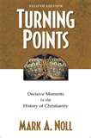

1. The Church pushed out on its own: The fall of Jerusalem (70 A.D.)
2. Realities of Empire: The Council of Nicaea (325 A.D.)
3. Doctrine, politics, and life in the Word: The Council of Chalcedon (451 A.D.)
4. The monastic rescue of the church: Benedict’s Rule (530 A.D.)
5. The culmination of Christendom: The coronation of Charlemagne (800 A.D.)
6. Division between East and West: The great schism (1054 A.D.)
7. The beginnings of Protestantism: The diet of Worms (1521 A.D.)
8. A new Europe: The English Acts of Supremacy (1534 A.D.)
9. Catholic reform and worldwide outreach: The founding of the Jesuits (1540 A.D.)
10. The new piety: The conversion of the Wesleys (1738)
11. Discontents of the modern west: The French Revolution (1789)
12. A faith for all the world: The Edinburgh Missionary Conference (1910)
13. Further turning points of the 20th century:
    * The rise and spread of Pentecostalism;
    * The Second Vatican Council of the Roman Catholic Church;
    * The emergence of women into greater public visibility;
    * The massive production of new Bible translations as an aspect, more generally, of the globalization of Christianity;
    * The survival of Christianity under Communist regimes.
      1. “Methodist” 是什么意思？

1729年，已被按立为牧师的卫斯理约翰和正在大学读书的弟弟卫斯理查理，在英国牛津大学中与几位大学生固定的聚会。由于他们追求敬虔的生活，看重祷告、禁食、查经、领圣餐，且积极进行怜悯之工，如探访监狱中的囚犯，甚至过节俭的生活以致有更多钱能帮助穷人，他们被大学同学**嘲笑为“圣社”（Holy Club）、“圣经蛀虫”（Bible Moths）、“份外功行者”（Supererogation Men），以及“照章办事者”（Methodist）**。

但他们择善固执，不以被称为“照章办事者”为耻，反认为敬畏上帝、有条有理、循规蹈距的生活是人生崇高的标竿。后来，由卫斯理兄弟在圣灵的大能中带动的灵性复兴运动，就被称为“循道运动”（Methodist Movement），为英国注入教会更新、社会革新的气息！

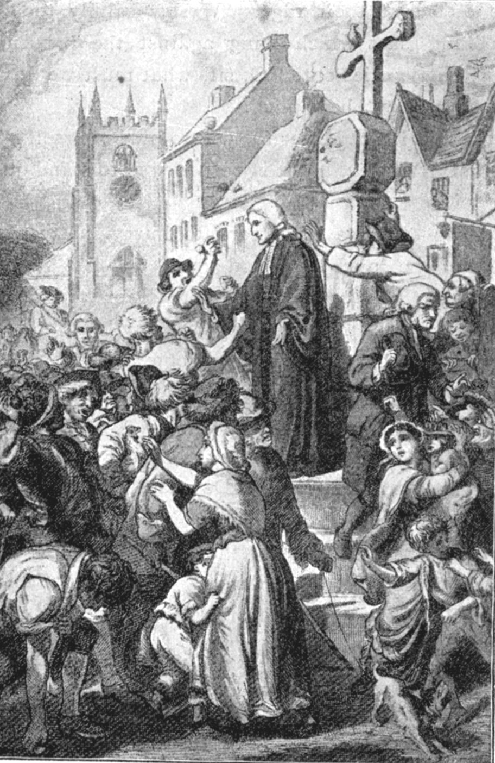 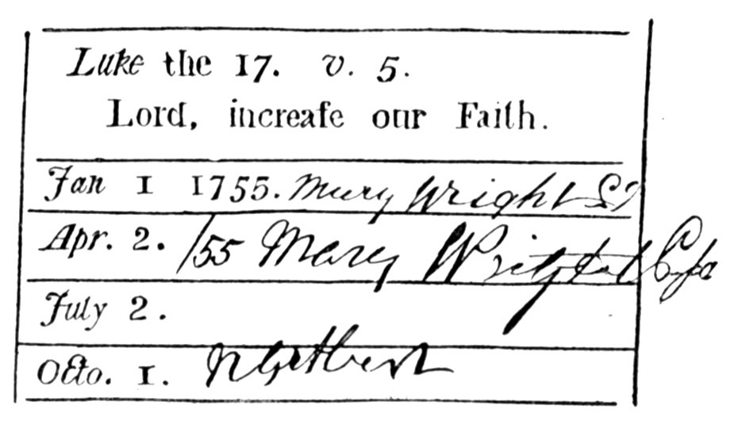 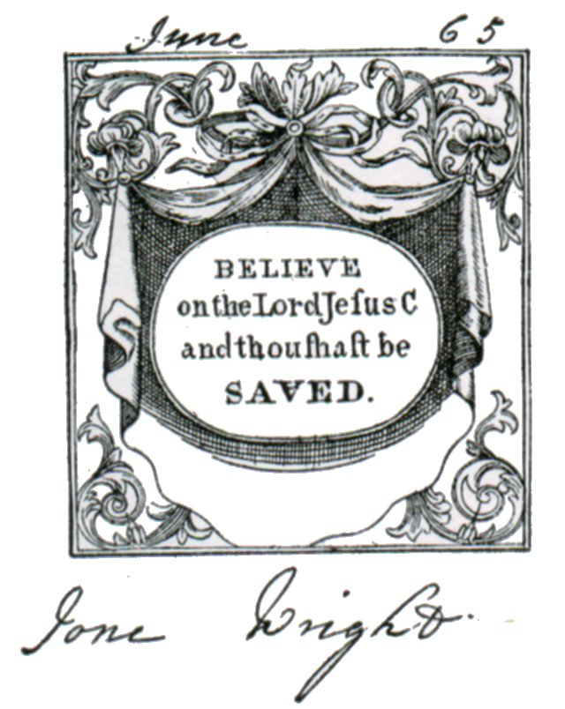

在1928年，英国圣公会坎特伯里大主教（Archbishop of Canterbury）蓝道尔.托马斯.戴维森（Randall Thomas Davidson）说：“卫斯理实际地改变了英国的光景，甚至是国家的质量”（“Wesley practically changed the outlook and even the character of the English nation”--- in *John Wesley and Charles Wesley, Songs and Sermons* [n.p.: Fount Classics, n.d.], vii）。

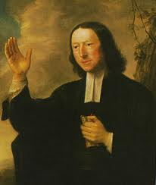 “What then is the mark? **Who is a Methodist**, according to your own account?” I answer: A **Methodist is one who has “the love of God shed abroad in his heart by the Holy Ghost given unto him;” one who “loves the Lord his God with all his heart, and with all his soul, and with all his mind, and with all his strength**. God is the joy of his heart, and the desire of his soul; which is constantly crying out, “Whom have I in heaven but thee? And there is none upon earth that I desire beside thee! My God and my all! Thou art the strength of my heart, and my portion for ever!”

He is therefore **happy in God**, yea, always happy, as having in him “a well of water springing up into everlasting life,” and overflowing his soul with peace and joy. “Perfect love” having now “cast out fear,” he “rejoices evermore.” He “rejoices in the Lord always,” even “in God his Saviour;” and in the Father, “through our Lord Jesus Christ, by whom he hath now received the atonement.” “Having” found “redemption through his blood, the forgiveness of his sins,” he cannot but rejoice, whenever he **looks back** on the horrible pit out of which he is delivered; when he sees “all his transgressions blotted out as a cloud, and his iniquities as a thick cloud.” He cannot but rejoice, whenever he **looks on the state wherein he now is**; “being justified freely, and having peace with God through our Lord Jesus Christ.” For “he that believeth, hath the witness” of this “in himself;” being now the son of God by faith. “Because he is a son, God hath sent forth the Spirit of his Son into his heart, crying, Abba, Father!” And “the Spirit itself beareth witness with his spirit, that he is a child of God.” He rejoiceth also, whenever he **looks forward**, “in hope of the glory that shall be revealed;” yea, this his joy is full, and all his bones cry out, “Blessed be the God and Father of our Lord Jesus Christ, who, according to his abundant mercy, hath begotten me again to a living hope – of an inheritance incorruptible, undefiled, and that fadeth not away, reserved in heaven for me!” (in “The Character of a Methodist,” 1742, *The Works of John Wesley*, 8:341-342).

**By Methodist I mean**, a people who profess to pursue (in whatsoever measure they have attained) **holiness of heart and life**, inward and outward conformity in all things to the revealed will of God; who place religion in an uniform resemblance of the great object of it; in a steady imitation of Him they worship, in all his imitable perfections; more particularly, in justice, mercy, and truth, or **universal love filling the heart, and governing the life**. [in “Advice to the people called Methodists”, 10 Oct 1745; Thomas Jackson, ed., *The Works of John Wesley*, 14 vols. (London: Wesleyan Methodist Book Room, 1872; Reprinted Grand Rapids, MI: Baker Books, 2007),8:352]

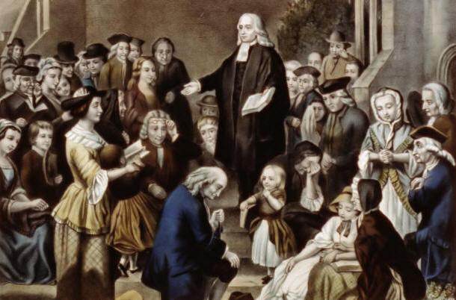 **Our main doctrines**, which include all the rest, are three---that of **repentance**, of **faith**, and of **holiness**. The first of these we account, as it were, the porch of religion; the next, the door; the third, religion itself.

**Religion itself…we define, “The loving God with all our hearts, and our neighbor as ourselves; and in that love abstaining from all evil, and doing all possible good to all men**…The [holy] love we believe to be the medicine of life, the never-failing remedy for all the evils of a disordered world, for all the miseries and vices of men. Whenever this is, there are virtues and **happiness** going hand in hand. There is humbleness of mind, gentleness, longsuffering, the whole image of God, and, at the same time, a peace that passeth all understanding, and joy unspeakable and full of glory. This religion we long to see established in the world, a religion of love, and joy, and peace; having its seat in the **heart**, in the inmost soul, but ever showing itself by its **fruits**; continually springing forth, not only in all innocence, (for love worketh no ill to his neighbor), but likewise in every kind of beneficence, spreading virtue and happiness all around it. (in “The Principles of a Methodist Farther Explained,” 1746, *The Works of John Wesley*, 8:472, 474, VI.4,6).

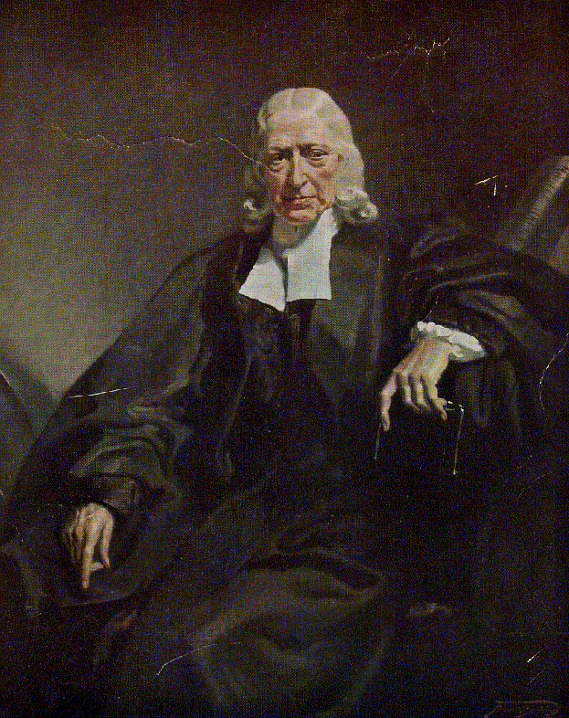 I AM not afraid that **the people called Methodists** should ever cease to exist either in Europe or America. But I am afraid, lest they should only exist as a dead sect, having the form of religion without the power. And this undoubtedly will be the case, unless they hold fast both the doctrine, spirit, and discipline with which they first set out…What was their fundamental doctrine? That the **Bible** is the whole and sole rule both of Christian faith and practice. Hence they learned, (1.) That religion is an **inward** principle; that it is no other than the mind that was in Christ; or, in other words, the **renewal of the soul after the image of God, in righteousness and true holiness**. (2.) That this can never be wrought in us, but by the **power** of the Holy Ghost. (3.) That we receive this, and every other blessing, merely for the sake of **Christ**: And, (4.) That whosoever hath the mind that was in Christ, the same is **our** brother, and sister, and mother.

Methodism, (so called,) any man of understanding may easily discern, that it is only plain, scriptural religion, guarded by a few prudential regulations. **The essence of it is holiness of heart and life**; the circumstantials all point to this. And as long as they are joined together in the people called Methodists, no weapon formed against them shall prosper. But if even the circumstantial parts are despised, the essential will soon be lost. And if ever the essential parts should evaporate, what remains will be dung and dross. (in “Thoughts Upon Methodism”, 4 Aug 1786; *The Works of John Wesley*, 13:260)

(二) 卫斯理的救恩观 ：

**卫斯理约翰的标准讲章The Standard Sermons of John Wesley**

**成为基督徒（Becoming a Christian）**

1. [Salvation by Faith](http://new.gbgm-umc.org/umhistory/wesley/sermons/1/)因信得救—Eph弗 2:8
2. [Almost Christian差一点就是真正的基督徒—](http://new.gbgm-umc.org/umhistory/wesley/sermons/2/)Acts徒 26:28
3. [Awake, Thou That Sleepest](http://new.gbgm-umc.org/umhistory/wesley/sermons/3/)你这睡觉的人当醒过来—Eph弗 5:14
4. The [Scriptural Christianity](http://new.gbgm-umc.org/umhistory/wesley/sermons/4/)合乎圣经的基督教—Acts徒 4:31
5. [Justification by Faith](http://new.gbgm-umc.org/umhistory/wesley/sermons/5/)因信称义—Rom罗 4:5
6. The [Righteousness of Faith](http://new.gbgm-umc.org/umhistory/wesley/sermons/6/)出于信心的义—Rom罗 10:5-8
7. The [Way of the Kingdom](http://new.gbgm-umc.org/umhistory/wesley/sermons/7/)天国之路—Mark可 1:15
8. The [First Fruits of the Spirit](http://new.gbgm-umc.org/umhistory/wesley/sermons/8/)圣灵的初果—Rom罗 8:1
9. The [Spirit of Bondage and of Adoption](http://new.gbgm-umc.org/umhistory/wesley/sermons/9/)奴仆的心和儿女的心—Rom罗 8:15
10. The [Witness of the Spirit,圣灵的印证 1](http://new.gbgm-umc.org/umhistory/wesley/sermons/10/)—Rom罗 8:16
11. The [Witness of the Spirit, 圣灵的印证2](http://new.gbgm-umc.org/umhistory/wesley/sermons/11/)—2 Cor林后 1:12
12. The [Witness of our own Spirit](http://new.gbgm-umc.org/umhistory/wesley/sermons/12/)自己良心的见证—2 Cor林后 1:12
13. [On Sin in Believers](http://new.gbgm-umc.org/umhistory/wesley/sermons/13/)信徒生命中罪的问题—2 Cor林后 5:17
14. The [Repentance of Believers](http://new.gbgm-umc.org/umhistory/wesley/sermons/14/)信徒的悔改—Mark可 1:15
15. The [Great Assize](http://new.gbgm-umc.org/umhistory/wesley/sermons/15/)大审判—Rom罗 14:10
16. The [Means of Grace](http://new.gbgm-umc.org/umhistory/wesley/sermons/16/)施恩的工具—Mal玛 3:7
17. The [Circumcision of the Heart](http://new.gbgm-umc.org/umhistory/wesley/sermons/17/)心的割礼—Rom罗 2:29
18. The [Marks of the New Birth](http://new.gbgm-umc.org/umhistory/wesley/sermons/18/)重生的记号—John约 3:8
19. [Great Privilege of Those that are Born of God](http://new.gbgm-umc.org/umhistory/wesley/sermons/19/)从上帝而生者所享有的特权—1 John约一 3:9
20. The [Lord Our Righteousness上帝是我们的义](http://new.gbgm-umc.org/umhistory/wesley/sermons/20/)—Jer耶 23:6

**身为基督徒（Being a Christian）**

1. [Sermon on the Mount,登山宝训 1](http://new.gbgm-umc.org/umhistory/wesley/sermons/21/)—Matt太 5:1-4
2. [Sermon on the Mount, 2](http://new.gbgm-umc.org/umhistory/wesley/sermons/22/)-- Matt 5:5-7
3. [Sermon on the Mount, 3](http://new.gbgm-umc.org/umhistory/wesley/sermons/23/)-- Matt 5:8-12
4. [Sermon on the Mount, 4](http://new.gbgm-umc.org/umhistory/wesley/sermons/24/)-- Matt 5:13-16
5. [Sermon on the Mount, 5](http://new.gbgm-umc.org/umhistory/wesley/sermons/25/)-- Matt 5:17-20
6. [Sermon on the Mount, 6](http://new.gbgm-umc.org/umhistory/wesley/sermons/26/)-- Matt 6:1-15
7. [Sermon on the Mount, 7](http://new.gbgm-umc.org/umhistory/wesley/sermons/27/)-- Matt 6:16-18
8. [Sermon on the Mount, 8](http://new.gbgm-umc.org/umhistory/wesley/sermons/28/)-- Matt 6:19-23
9. [Sermon on the Mount, 9](http://new.gbgm-umc.org/umhistory/wesley/sermons/29/)-- Matt 6:24-34
10. [Sermon on the Mount, 10](http://new.gbgm-umc.org/umhistory/wesley/sermons/30/)-- Matt 7:1-12
11. [Sermon on the Mount, 11](http://new.gbgm-umc.org/umhistory/wesley/sermons/31/)-- Matt 7:13-14
12. [Sermon on the Mount, 12](http://new.gbgm-umc.org/umhistory/wesley/sermons/32/)-- Matt 7:15-20
13. [Sermon on the Mount, 13](http://new.gbgm-umc.org/umhistory/wesley/sermons/33/)-- Matt 7:21-27

**忠为基督徒（Remaining a Christian）**

1. The [Origin, Nature, Properties, and Use of the Law](http://new.gbgm-umc.org/umhistory/wesley/sermons/34/)律法的起源、性质、性能和用处—Rom罗 7:12
2. The [Law Established through Faith,信心坚固律法 1, The](http://new.gbgm-umc.org/umhistory/wesley/sermons/35/)—Rom罗 3:31
3. The [Law Established through Faith, 信心坚固律法2, The](http://new.gbgm-umc.org/umhistory/wesley/sermons/36/)—Rom罗 3:31
4. The [Nature of Enthusiasm](http://new.gbgm-umc.org/umhistory/wesley/sermons/37/)狂信的性质—Acts徒 26:24
5. A [Caution against Bigotry](http://new.gbgm-umc.org/umhistory/wesley/sermons/38/)对顽固的警告—Mark可 9:38-39
6. [Catholic Spirit](http://new.gbgm-umc.org/umhistory/wesley/sermons/39/)大公精神—2 Ki王下 10:15
7. [Christian Perfection](http://new.gbgm-umc.org/umhistory/wesley/sermons/40/)基督徒的完全—Phil腓 3:12
8. [Wandering Thoughts](http://new.gbgm-umc.org/umhistory/wesley/sermons/41/)流离的思想—2 Cor林后 10:5
9. [Satan's Devices](http://new.gbgm-umc.org/umhistory/wesley/sermons/42/)撒但的诡计—2 Cor林后 2:11
10. The [Scripture Way of Salvation](http://new.gbgm-umc.org/umhistory/wesley/sermons/43/)圣经所启示的救恩之路—Eph弗 2:8
11. [Original Sin](http://new.gbgm-umc.org/umhistory/wesley/sermons/44/)原罪—Gen创 6:5
12. The [New Birth](http://new.gbgm-umc.org/umhistory/wesley/sermons/45/)重生—John约 3:7
13. The [Wilderness State](http://new.gbgm-umc.org/umhistory/wesley/sermons/46/)在旷野中的状况—John约 16:22
14. [Heaviness through Manifold Temptations](http://new.gbgm-umc.org/umhistory/wesley/sermons/47/)诸多试探中的重担—1 Pet彼前 1:6
15. [Self-Denial](http://new.gbgm-umc.org/umhistory/wesley/sermons/48/)舍己—Luke路 9:23
16. The [Cure of Evil Speaking恶言的医治](http://new.gbgm-umc.org/umhistory/wesley/sermons/49/)—Matt太 18:15-17
17. The [Use of Money钱财的使用](http://new.gbgm-umc.org/umhistory/wesley/sermons/50/)—Luke路 16:9
18. The [Good Steward](http://new.gbgm-umc.org/umhistory/wesley/sermons/51/)好管家—Luke路 21:2
19. The [Reformation of Manners](http://new.gbgm-umc.org/umhistory/wesley/sermons/52/)举止的改造—Ps诗 94:16
20. [On the Death of Mr. Whitefield](http://new.gbgm-umc.org/umhistory/wesley/sermons/53/)缅怀怀特腓—Num民 20:10

[](http://rds.yahoo.com/_ylt=A2KJkIcvq7BNk3YAzpuJzbkF;_ylu=X3oDMTBqNzBoY2J0BHBvcwMxNARzZWMDc3IEdnRpZAM-/SIG=1hi9vc150/EXP=1303452591/**http:/images.search.yahoo.com/images/view?back=http://images.search.yahoo.com/search/images?p=pure+in+heart&ei=utf-8&fr=yfp-t-701&w=1800&h=2138&imgurl=webpages.charter.net/pureheart/_borders/logo.jpg&rurl=http://webpages.charter.net/pureheart/&size=194KB&name=Pure+Heart+Minis...&p=pure+in+heart&oid=0b36fdf9ee26edca71a4249171ffa25e&fr2=&no=14&tt=418000&sigr=1164ib0a6&sigi=11g7nm3m8&sigb=12i5een23&.crumb=J1X9DHG6kRp) **Standard Sermon 1: Salvation by Faith** “Christian faith is then, not only an assent to the whole gospel of Christ, but also a full reliance on the blood of Christ; a trust in the merits of his life, death, and resurrection; a recumbency upon him as our atonement and our life, as *given for us*, and *living in us*…

[T]hrough this faith they are saved from the power of sin, as well as from the guilt of it…A salvation from sin, and the consequences of sin, both often expressed in a word justification; which taken in the largest sense, implies a **deliverance from guilt and punishment**, by the atonement of Christ actually applied to the soul of sinner now believing on him, and a **deliverance from the power of sin, through** **Christ formed in his heart**.

So that he who is thus justified, or saved by faith, is indeed born again. He is *born again of the Spirit* unto a new life, which ‘is hid with Christ in God.’ And as a new-born babe he gladly receives the “sincere milk of the word, and grows thereby;’ going on in the might of the Lord his God, **from faith to faith, from grace to grace**, until, at length, he come unto ‘a perfect man, unto the measure of **the stature of the fullness of Christ**.”

Thomas Jackson, ed., *The Works of John Wesley,* 14 vols*.* (London: Wesleyan Methodist Book Room, 1872; Reprinted Grand Rapids, MI: Baker Books, 2007), 5:9, 11-12.

**Sermon 86: “Working Out Our Own Salvation” (1785)**

Salvation begins with what is usually termed (and very properly) ***preventing* *grace***; including the first wish to please God, the first dawn of light concerning his will, and the first slight transient conviction of having sinned against him. All these imply some tendency toward life; some degree of salvation; the beginning of a deliverance from a blind, unfeeling heart, quite insensible of God and the things of God.

Salvation is carried on by ***convincing* *grace***, usually in Scripture termed repentance; which brings a larger measure of self-knowledge, and a farther deliverance from the heart of stone.

Afterwards we experience the proper Christian salvation; whereby, “through *grace*,” we “are saved by faith;” consisting of those two grand branches, ***justification* *and* *sanctification***. By justification we are saved from the guilt of sin, and restored to the favour of God; by sanctification we are saved from the power and root of sin, and restored to the image of God.

All experience, as well as Scripture, shows this salvation to be both instantaneous and gradual. It **begins the moment we are justified**, in the holy, humble, gentle, patient love of God and man. It **gradually increases from that moment**, as “a grain of mustard-seed, which, at first, is the least of all seeds,” but afterwards puts forth large branches, and becomes a great tree; till, **in another instant, the heart is cleansed, from all sin, and filled with pure love to God and man**. But even that love increases more and more, till we “grow up in all things into him that is our Head;” till we attain “the measure of the stature of the fullness of Christ.”

拯救，始于通常被称为（这也是正确的）**先设或先赐恩典**；［这］包括第一个要讨上帝喜悦的意愿、第一个关乎上帝旨意的光照，和第一次细小且片刻的为得罪上帝而知罪的经验。这一切意表［罪人］朝向生命的某些倾向，某程度的拯救，好［令罪人］开始从一颗瞎了且无感觉的心解救出来，即从对上帝和关乎上帝之事的麻木中释放出来。拯救在**使人信服之恩**中继续，其在圣经中通常被称为**悔改**。它带来更大程度的自知，并更进一步的解救石心。接下来，我们就经历真正的基督徒的拯救，即本乎恩，因着信，我们得救了。这拯救包涵两个崇高的部份－**称义和成圣**。借着称义，我们从罪孽中被拯救，且被恢复至蒙上帝悦纳的地位；借着成圣，我们则是从罪恶的权势和罪根中被拯救，而恢复上帝的形像。所有的经验，以及圣经本身，都显示这拯救是瞬间，也是逐渐的。它始于我们被称义的时刻，即对上帝和人有着圣洁、谦卑、温柔、忍耐的爱中。从那时刻起，它逐渐增长－好像一粒“芥菜种，原是百种里最小的”，但后来长起来，却成了大树－一直到另一个时刻，我们心中所有的罪［性］被洁净，而对上帝和人充满着纯洁的爱。但是，就连这份爱也会越发增长，一直到我们达到“ 满有基督长成的身量”。

Thomas Jackson, ed., *The Works of John Wesley,* 14 vols*.* (London: Wesleyan Methodist Book Room, 1872; Reprinted Grand Rapids, MI: Baker Books, 2007), :8.

**Hymn: “O For a Thousand Tongues to Sing”** Words: Charles Wesley, 1739. Music: Carl G. Glaser, 1839.

1. O for a thousand tongues to sing my great Redeemer's praise,  
the glories of my God and King, **the triumphs of his grace**!

2. My gracious Master and my God, assist me to proclaim,  
to spread through all the earth abroad the honors of thy name.

3. Jesus! the name that charms our fears, that bids our sorrows cease;  
'tis music in the sinner's ears, 'tis life, and health, and peace.

4. He breaks the power of canceled sin, he sets the prisoner free;  
his blood can make the foulest clean; his blood availed for me.

5. He speaks, and listening to his voice, new life the dead receive;  
the mournful, broken hearts rejoice, the humble poor believe.

6. In Christ, your head, you then shall know, shall feel your sins forgiven;  
anticipate your heaven below, and own that love is heaven.

1 哦，愿我有千万舌头，前来赞美救主，说祂恩典何等深厚，荣耀何等丰富。

2 耶稣这名慰我苦情，驱尽我的惊怯，是我安息、是我生命，成为我的音乐。

3 祂因爱我，竟愿经历，人世所有苦楚；祂已消灭罪的能力，释放罪的囚徒。

4 我每静念救我的爱，立即感觉不配；不知祂为甚么恩待，我这人中罪魁。

5 我今作祂爱的俘虏，甘心作到永久；因祂为我受死、忍辱，使我得以自由。

6 我既从你可爱的名，知你待我美意；假若我有千万的心，也当一一归你。

上帝的主权和慈爱，恩上加恩，圣洁又喜乐

1. 先备预设的恩典(约1:9;罗2:14-15)

“如果我们从极广意的方面来看救恩［salvation］，它就包括那常被称为“天然良心”［natural conscience］在人灵魂中的各种工作；但其实，这良心的工作就是“预设或先赐恩典”［preventing grace］。其包括：天父的吸引，以致我们若愿意降服的话，我们对上帝的渴慕就会与日俱增；上帝的儿子“照亮一切生在世上之人”的所有光辉，指示每个人“行公义，好怜悯，存谦卑的心与上帝同行”；以及圣灵不时在每一个人心里所激起的知罪之心，虽然人往往尽快抑制它，而因此过了不久后便忘记，或甚至否认他们曾有这些经历。”

［取自：卫斯理约翰标准讲章第43篇“圣经所显示的拯救方法”The Scripture Way of Salvation］

1. 认罪悔改的恩典(约16:7-11)

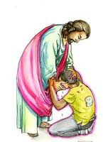

“常在信心之前就有的悔改或知罪…我们是如此描述的：当一个人感受罪孽深重，又看见其工价就是灭亡，而且心思眼见地狱的恐怖时，他们战抖，且被哀恸深触内心。他们不禁自责，并向上帝敞露他们的忧伤，呼求上帝的怜悯…恳切渴望从地狱和遭灭的危险中被释放，甚至废寝忘食，憎恶世俗的事物和快乐。”（参卫氐1746年的文章“The Principles of A Methodist Farther Explained”）

“现在，［称义重生之前的］悔改不只是单一表现而已。它乃是诸多表现的集合，其中包括：(1) 为罪哀恸；(2) 在上帝的手下降卑；(3) 恨罪；(4) 认罪；(5) 恳切祈求上帝的怜悯；(6) 爱上帝；(7) 停止行恶；(8) 立志有新的顺服；(9) 归还以不正当手段得来的东西；(10) 饶恕得罪我们的邻舍；(11) 行善或施舍。”（参卫氐1741年的讲章“Hypocrisy in Oxford”）

1. 领受信心的恩典(弗2:8-9)

在公元第十八世纪时，身为圣公会之牧师第十五个儿子的卫斯理约翰，也有多年想立自己的义，即不凭着信心求，只凭着行为追求律法的义。

当**年少**的他在伦敦寄宿学校读书时，他的观念是：“我仍早晚读圣经和祷告；而我期望能因下列因素得救： (1) 没有像其他人那么坏；(2) 仍对信仰有好感；(3) 读圣经、去教会，和祷告。”

到了1729年，当他26岁时，已在圣公会中被**按立**，且已在牛津大学修毕硕士学位的他，仍然认为：“借着我尽心竭力，在内心里和外在生活上，都不断遵行上帝所有律法的努力，我深信我应该会被上帝接纳，即得救。”

但到了1738年，35岁的卫斯理约翰，在历经了北美新殖民地近两年的宣教与牧养的困难，以及感情生活上的挫折之后，他想立自己的义的观念开始动摇。当他**由北美返回英国**时，他在一月八日的日记中写：“我承认我自己的不信［因对死亡有挥不去的恐惧］…骄傲－由于在过去的日子中，我曾认为自己拥有我所其实没有的…主啊，救我，否则我会灭亡！救我！”到了二月一日，当他抵达英国时，他的日记显示，他那想立自己的义的信念真是彻底瓦解：

是不是我所做的一切，所知道的，所说的，所给予的，所行的，或所受的痛苦，在祂眼中可蒙称义？是不是我的不断地遵奉各种施恩的工具（虽然这是本份内的事），或是我的“不觉得自己有错”，在外表上的刚毅，在道德上的正直无瑕疵等，在祂眼中可蒙称义？或是（更进一步）对基督教的所有真理，有着合乎理性的信念，可蒙称义？是不是这一切可以使我称为是一个具有圣洁的，属天的和神圣品格的基督徒？不！绝对不是！…那么，我走到地极所学到的，不过是这一点：我亏欠了上帝的荣耀…我所要的信仰是“对上帝坚定的倚靠与信心，即透过基督的功劳，我的众罪孽全蒙赦免，并使我与上帝复和。

　　接下来，在三月与四月间，上帝透过一位宣教士伯勒尔（Peter Bohler）引导约翰明白，原来，真正的得救信心，其本质不但是关乎一个人对上帝的一种坚定信靠（即单单相信借着基督的宝血功劳，人的罪可蒙赦免，与上帝和好），它亦关乎两个重要的果子－成圣和喜乐（holiness and happiness）。还有，更妙的是，伯勒尔帮助卫斯理约翰暸解，这种得救的信心是上帝瞬间的恩赐！换句话说，一个自知十恶不赦，深感罪孽深重，且有认真悔过之心的人，可在一瞬间，从上帝领受单纯信靠基督宝血的得救信心，而因此即刻由黑暗转为光明，由罪污和痛苦转为公义和圣灵里的喜乐！

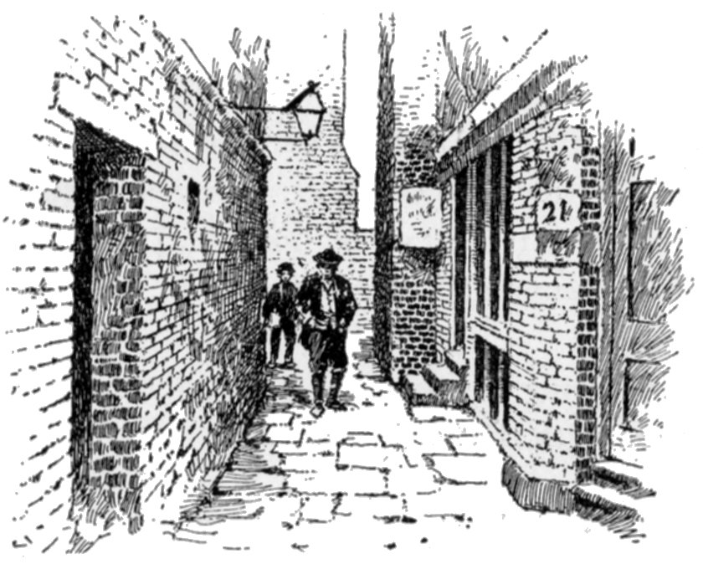最后，在**五月廿四日（星期三）晚上**，卫斯理约翰终于亲身经历上帝那赐人得救信心，且赐人称义之乐的瞬间恩赐。他在日记中写：

晚上我很勉强的去参加一个在亚得门街的聚会。会中有人宣读路德所写的“罗马书信序文”。八时四十五分左右，当他描述上帝借着人对基督的信心，在人心里面所施行的改变时，**我觉得心中奇异的温暖。我觉得自己确实已信靠基督，而且是单靠基督得救。此外，我也获得确据，即祂已除去我的罪，正是我的罪，救我脱离了罪和死的律。**”

在一封写于十月的信件中，他说：“我不是一位基督徒，一直到五月廿四日。因为，在这之前，罪恶统治我，但在这之后，直到如今，罪恶并不再有主权。这是上帝的白白恩典！

Minutes of Some Late Conversations between the Rev. Mr. Wesleys and Others: Conversation I (Monday, June 25th, 1744)

Q. 4. What is faith? Faith in general is a divine, supernatural conviction of things not seen; that is, of past, future, or spiritual things: It is a spiritual sight of God and the things of God. First the sinner is convinced by the Holy Ghost. “Christ loved me, and gave Himself for me.” **This is that faith by which he is justified, or pardoned, the moment he received it.** Immediately, the same Spirit bears witness, “Thou art pardoned; thos hast redemption in his blood.” And this is saving faith, whereby the love of God is shed abroad in his heart. (*The Works of John Wesley*, 8:276)

Conversation III (Tuesday, May 13th, 1746)

Q.14. But can it be conceived that God has any regard to the sincerity of an unbeliever? Yes, so much, that, is he persevere therein, **God will infallibly give him faith**.

1. 称义重生的恩典(罗4:5;约一3:9)

1748年讲章“那些从上帝而生者的大特权”：

|  |  |
| --- | --- |
| **称义（Justification）** | **重生（The New Birth）** |
| 1. 是关系上的变化（ relative change）； 2. 是上帝藉基督为我们作的事（God does something forus）； 3. 改变我们与上帝的关系，由与神为敌变成上帝的儿女； 4. 恢复了蒙上帝悦纳的地位； 5. 除去罪孽。 | 1. 是实质的变化（real change） 2. 是上帝藉圣灵在我们生命里作的事（God does something in us） 3. 改变内在的灵魂或人，由罪人变成圣徒； 4. 恢复了上帝的形像； 5. 除去罪的权势。 |

Standard Sermon 18 (1748) “The Marks of the New Birth”

I.4. An immediate and constant fruit of this faith whereby we are born of God…is **power** over sin; ---power over outward sin of every kind; over every evil word and work…---and over inward sin; for it purifieth the heart from every unholy desire and temper.

I.7. Another fruit of this living faith is **peace**. For, “being justified by faith,” having all our sins blotted out, “we have peace with God, through our Lord Jesus Christ.”…Whether they are in ease or in pain, in sickness or health, in abundance or want, they are happy in God.

例证：席子直–席胜魔 (1830-69)

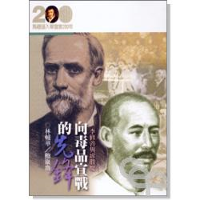

1. 得救确据的恩典(罗8:15-16)





1. 悔改成圣的恩典(林后5:17; 7:1; 约一1:9)

讲章“信徒里面的罪”（Sin in Believers）：

每一位在基督里的婴孩都是圣洁的［因罪孽赦了，罪刑免了，罪权除了］，但不完全是。他是从罪中得拯救了，但并未完全。罪仍余存，但它不再掌权［It remains, though it does not reign］…罪孽［the guilt of sin］是一回事，罪的权势［the power］是另一回事，而罪性［the being］也是另一回事。我们同意，信徒是已经从罪孽和罪的权势中被解救出来了，但我们不接受他们已经从罪性中被解救出来的说法…一个人可以有圣灵内住，而且真是随圣灵而行，但他仍感觉到“情欲与圣灵相争”。

讲章“圣经所显示的拯救方法”（The Scripture Way of Salvation）详细的描述“福音中的悔改”（Evangelical Repentance）：

在**称义以后的悔改**，是与从前［称义之前］的悔改截然不同的。它不包含罪债，也没有被定罪的恐惧，亦无活在上帝震怒之下的感受…它是由圣灵的工作而带来的觉悟，即使我们**觉悟到心里仍有**罪根…虽然这罪不再做主了，现在也不再统治［我们］了。这悔改是觉悟我们有那倾向罪恶之心、倾向背谬之心，［以及］肉体的情欲不断对抗圣灵的倾向。有时，除非我们不住的儆醒和祷告，［我们的心］就会发出骄傲、有时愤怒、有时贪爱世界、好安逸、爱荣誉、好享乐胜于爱上帝。这悔改是觉悟到我们那倾向自以为是的心，那倾向无神思想或拜偶像的心；最重要的是，那不信的心，使我们往往以千万个方法和在千万种借口中，或多或少离开了活的上帝…

有了这种觉悟，知道罪仍余存在我们的心里，就连带也有**另一个清楚的觉悟，即罪也黏着我们一切的言语和行为**。甚至在最好的言行上，我们现在可以看出有罪恶混杂在其中…我们发现自己沾染了骄傲、自我意愿、不信、拜偶像…经验告诉我们，即然觉悟到罪恶尚留在我们心里，并黏着我们所有的言语和行为…［福音中的］悔改就包含另一要素：即**觉悟到我们的无助**，我们是那么全然地不能想一个好的思想，或产生一个好的渴望，讲一句对的话，或表现一个好的行动，除非是透过上帝白白大能的恩典先赐给我们，并时刻伴随我们。

在同一篇讲章里，卫斯理也指出，福音中的悔改必结两种果实：

* 所有**敬虔之工**，如公共祷告会、家庭礼拜、密室中的祷告；领受圣餐；以聆听、诵读、默想的方式研究圣经；尽我们肉体健康所允许的实行禁食和斋戒。
* 所有**怜悯之工**，无论是关于灵魂或肉体方面的，如喂饱饥饿的人、给赤身露体的人穿、款待远客、看顾在监牢里的、患病的或遭遇各样患难的；又如竭力引导无知者、唤醒愚昧的罪人、激发那些不泠不热的、坚固信心动摇的、安慰意志薄弱的、援助被试探的，或不计代价拯救灵魂脱离死亡。

1. 全然成圣的恩典(帖前5:23-24;太22:37-40)

[](http://www.google.co.uk/url?sa=i&rct=j&q=&esrc=s&source=images&cd=&cad=rja&uact=8&docid=9DRjNywWY7bZoM&tbnid=3FJJEhl2lcIY9M:&ved=0CAUQjRw&url=http://www.freeimages.com/photo/1162404&ei=hp_IU4atMYqs0QXd2YDgCg&bvm=bv.71198958,d.ZGU&psig=AFQjCNGFq6PbBDkx7wuygM5LTf4xTlSQng&ust=1405743361542802)

Sermon 40: Christian Perfection (1741)

*Phi. 3:12: “Not as though I had already attained, either were already perfect.”*

1. **In what sense Christians are not perfect?**
2. **not perfect in knowledge or exempted from ignorance:**
3. We may know:
4. Many things related to the present world;
5. The world to come which God has revealed;
6. The mighty works of the Holy Spirit in our hearts;
7. What God requires for daily life and how to keep a clear conscience.
8. But we don’t know or we know very little about:
9. The perfect God, Trinity, incarnation;
10. Times when God will work his great works on earth;
11. When God will hasten his kingdom as the number of his elect is fulfilled;
12. The visible works of God’s hand in creation.
13. **not exempted from mistake**:
14. Reason: We know but in part, thus are ever liable to err.
15. Children of God do not mistake as to the things essential to salvation. But in things inessential to salvation, children of God do err, even frequently, with regard to facts, and circumstances.
16. With regard to understanding the Bible, the best of people daily err about its meaning, even all Christians do not agree on the interpretation of many passages in the Bible.
17. **not exempted from infirmities**:

Definition: not known sins, but bodily infirmities, all those inward or outward imperfection (e.g., slowness of understanding, slowness of speech, impropriety of language).

1. **not exempted from temptations**:
2. Some seems to be without temptation because they resist not all uncleanness.
3. Many are fast asleep in a deed form of godliness, so Satan do not tempt them to outrageous sin, for fear that they would awaken before they drop into hell.
4. Some children of God for the present feel no temptation because God had said to the enemies to not touch/harm them. But this state of freedom from temptation will not last, because even Son of God himself, in the days of his flesh, was tempted to the end of his life.
5. **Christian perfection is another term for holiness.** How much soever any man has attained, or in how high a degree soever he is perfect, he hath still **need to “grow in grace,”** and daily to advance in the knowledge and love of God his Savior.

[](http://www.google.com.my/url?sa=i&rct=j&q=&esrc=s&source=images&cd=&cad=rja&uact=8&ved=0CAcQjRw&url=http://www.spanishdict.com/answers/264675/the-english-word-of-the-dayla-palabra-en-ingls-del-da-grow-crecer-cultivar-llenar-algo&ei=oYbQVMHYDoe1mwXJlILwCA&bvm=bv.85076809,d.dGc&psig=AFQjCNGWqKTKJJNW3Ma-pK9azSvcctOJZg&ust=1423038138554137)

1. **In what sense Christians are perfect?**

|  |  |
| --- | --- |
| Stages in Christian Life | Apostle John speaks of three stages:   1. The **little children**: sins forgiven, justified freely, have peace with God in Jesus → 2. The **young men**: have overcome the evil, strong, word of God abides in them, have quenched the fiery darts of evil, the witness of God that their sins are forgiven abide in their hearts → 3. **The father**: have known God from the beginning, known the Trinity and have become ***perfect* men, growing up to the measure of the stature of the fullness of Christ**. |
| Significance of Perfection | 1. The “fathers” or perfect Christians do not commit sin:  * Although Abraham, Moses, David, all did commit sin, that does not infer all Christians do and must commit sin as they live.      1. “Perfect” Christian is strong in the Lord---**freed from**:  * **evil thoughts**: bringing into captivity every thought to the obedience of Christ and bear good fruit; * **evil tempers**: be perfect as the heavenly Father is perfect; love enemies; crucified with Christ; with Christ living in him, thus all that is holy, just and good live in him too; hearts purified by faith from **pride, self-will, anger**.  1. Perfect Christians are like Jesus in this world, not at/after death (1 John 4:17, 1 John 1:5-9) 2. Perfection is God’s promise: Deut. 30:6; Ps. 51:10; Ez. 36:25; 2 Cor. 7:1. Perfection is the glorious liberty of the sons of God! |

**Hymn: Love Divine, All Loves Excelling** Words:Charles Wesley, 1747. Music:John Zundel, 1870

1. Love divine, all loves excelling, joy of heaven, to earth come down;   
fix in us thy humble dwelling; all thy faithful mercies crown!   
Jesus thou art all compassion, pure, unbounded love thou art;   
visit us with **thy salvation**; enter every trembling heart.

2. Breathe, O breathe thy loving Spirit into every troubled breast!   
Let us all in thee inherit; let us find that second rest.   
Take away our bent to sinning; Alpha and Omega be;   
end of faith, as its beginning, set our hearts at liberty.

3. Come, Almighty to deliver, let us all thy life receive;   
suddenly return and never, nevermore thy temples leave.   
Thee we would be always blessing, serve thee as thy hosts above,   
pray and praise thee without ceasing, glory in thy perfect love.

4. Finish, then, thy new creation; **pure and spotless** let us be.   
Let us see thy great salvation perfectly restored in thee;   
changed from glory into glory, till in heaven we take our place,   
till we cast our crowns before thee, lost in wonder, love, and praise.

1. 神圣纯爱超乎万爱，天上欢乐降人间，  
   恳求屈尊居我心中，超过寻常恩万般，  
   耶稣主是万爱结晶，怜悯慈悲集大成，  
   求携救恩惠然来临，进入颗颗战栗心。
2. 恳求主将爱的精神，吹入每颗烦恼心，  
   主所应许甜蜜安息，但愿人人得继承，  
   恳求去掉爱罪心怀，成全我灵始与终，  
   信的结果美如开端，自由释放我心衷。
3. 全能神阿求来救拯，容我接受主生命，  
   我心主殿愿主忽临，永不永不离我心，  
   但愿时常颂主事主，犹如天上众天军，  
   祈祷赞扬永无停止，完全爱里永欢欣。
4. 求主完成再造深恩，使我洁清无瑕疵，  
   使我能见宏大救恩，再得归回主爱里，  
   愿从光荣再进光荣，身列天班长供奉，  
   到时冠冕主前抛掷，忘形爱颂惊奇中。
5. 永生荣耀的恩典(启21:5;西3:4;约一3:2)

**Sermon 64: “The New Creation” (1785)**

Hence will arise an unmixed state of holiness and happiness far superior to that which Adam enjoyed in paradise… And to crown all, there will be a deep, an intimate, an uninterrupted union with God; a constant communion with the Father and his Son Jesus Christ, through the Spirit; a continual enjoyment of the Three-One God, and of all the creatures in him!” (Outler, ed., Sermons, 2:510)

(三) 卫斯理的门训观 ：

**1. 教导真理Teachable and Teach:**

教导圣经恩上加恩的真理使信徒雄心勃勃的活！

卫斯理约翰曾在年议会里如此回答一个关乎复兴的问题：

“在复兴衰微的地方，有何可作的事，以复兴上帝的工作？”

* 1. 让每位传道人细心的读［宣教士］“戴维布莱纳的生平事迹”…效法他如同他效法基督；
  2. 让助手和传道人都精确的在循道纪律上勤勉认真；
  3. 确保每一个巡回牧区都有传道人；
  4. 指定祷告会；
  5. 让所有的会社都禁食；
  6. 更积极分发书本，特别是讲章－“好管家”、“内在的罪”、“信徒的悔改” 、“圣经所显示的拯救方法”；
  7. 强有力和明确的劝勉所有信徒竭力进到完全的地步！

“The Principles of a Methodist Farther Explained” (*The Works of John Wesley* 8:472, 474):

VI.4 Our main doctrines, which include all the rest, are three---that of **repentance**, of **faith**, and of **holiness**. The first of these we account, as it were, the **porch** of religion; the next, the **door**; the third, **religion** itself.

VI.6 Religion itself…we define, “The **loving God with all our hearts, and our neighbor as ourselves**; and in that love abstaining from all evil, and doing all possible good to all men…The love we believe to be the medicine of life, the never-failing remedy for all the evils of a disordered world, for all the miseries and vices of men. Whenever this is, there are virtues and **happiness** going hand in hand. There is humbleness of mind, gentleness, longsuffering, the whole image of God, and, at the same time, a peace that passeth all understanding, and joy unspeakable and full of glory. This religion we long to see established in the world, a religion of love, and joy, and peace; having its seat in the heart, in the inmost soul, but ever showing itself by its fruits; continually springing forth, not only in all innocence, (for love worketh no ill to his neighbour), but likewise in every kind of beneficence, spreading virtue and happiness all around it.

**2. Together:**

增加圣徒灵力和凝聚力建立同心同行的团队！

[](http://www.google.com.my/url?sa=i&rct=j&q=&esrc=s&source=images&cd=&cad=rja&uact=8&ved=0CAcQjRw&url=http://www.softballexcellence.com/dugout/miscellaneous/power-of-team/&ei=NdtjVMCFOc6EuwTeyoC4Aw&bvm=bv.79189006,d.c2E&psig=AFQjCNF5Hp6rnFHcSag_V_BlzS_7o6VD9Q&ust=1415916631511506)

1. “上帝制定的基要恩典管道”：

祷告禁食

研读圣经

领受圣餐

崇拜团契

“联合会社”(United Society): 较大群；不一定是信徒；目的是逃避将来的忿怒,且从罪中得救赎；一般规则是不行恶、尽行善、遵行道。

Cognitive instruction and education---open for all (Phi. 2:12)

“班会”(Class meeting)：12人。

Behavioral supervision and change---compulsory (Heb. 10:23-25; 1 Cor. 14:3)

“小团”(Band)：5-10人，已婚或单身男女各聚；更紧密联系；规则是要彼此认罪和代祷，使大家得医治；强调把生命的真实情况说出。

Affective redirection---voluntary; free and honest sharing of emotions and values (James 5:16)

“精选会社”(Select Society)：培育追求基督徒完全的信徒领袖，改进每一种才干，使他们成为善行的模范。

“悔罪者团契”(Penitents)：恢复泠淡退后者的起初爱心。

家庭灵修祈祷

1. “信徒精用的多元恩典管道”：按成长的阶段和需要而谨慎精明设定的方法，在彼此守望督促之中，实践敬拜灵修和怜悯公义之工。

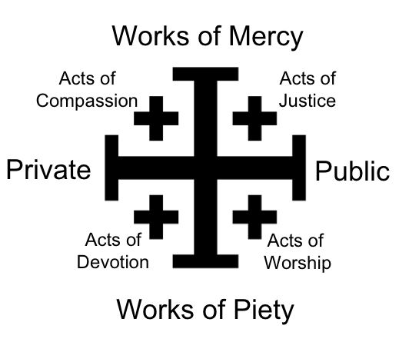

**3. Touching our neighbors, society and nations:**

灌输信徒社会圣洁匹夫有责，任重道远的概念！



1. “给我一百个除了罪恶别无所惧﹐**除了神别无所慕**的传道**者**﹐不管他们是神职人员或是信徒他们将要**震动地狱之门﹐在地上建立天国**。”
2. “转化国家，特别是教会，并**在全地**宣扬圣经圣洁。

Minutes of Some Several Conversations between the Rev. Mr. Wesley and Others; From the year 1744 to the year 1789.

Q. 3. What may we reasonably believe to be **God’s design** in raising up the Preachers called Methodists? To reform the nation and, in particular, the Church**; to spread scriptural holiness over the land**.

*General Rules –* ***avoiding evil*** *of every kind;* ***doing good*** *of every possible sort, as far as possible,* ***to all men****.*

1. 属灵争战

普天颂赞418首《基督精兵歌》：“仰赖万军之将，何惧仇敌刚强？靠主能力向前争战，我军锐气莫当…靠主力量加增，警醒，祈求，争战：魔鬼权能完全破灭！高歌同庆凯旋。”

基本概念：

* 基督徒穿戴上帝所赐的全副军装（真理腰带、公义护心镜、平安福音鞋、信心蕂牌、救恩头盔、圣灵宝剑），单单倚靠救赎主耶稣基督在我们生命中持续运行的权能及圣灵的大能，
* 胜过魔鬼的权势（strength/force--它藉罪恶和死亡辖制支配世界），抵挡撒但的诡计（subtilty/fraud--不断以邪恶的权势和谎言来反抗信心、爱、圣洁，且努力将不信的恶心、骄傲、偶像崇拜、恶意、嫉妒、忿怒、仇恨灌输给人），
* 斥责赶逐污鬼邪灵而且身心不受其害，
* 唤醒人悔改归主，过圣洁的生活，使上帝的国降临在人身上和世界中。

Standard Sermon 38: A Caution Against Bigotry “对顽固的警告”(1750)

“[E]very minister of Christ does cast them out…**By the power of God attending his word, he brings these sinners to repentance; an entire inward as well as outward change, from all evil to all good. And this is, in a sound sense, to cast out devils**, out of the souls wherein they had hitherto dwelt. The strong man can no longer keep his house. A stronger than he is come upon him, and hath cast him out, and taken possession for himself, and made it a habitation of God through his Spirit. Here, then, the energy of Satan ends, and the Son of God “destroys the work of the devil.” The understanding of the sinner is now enlightened, and his heart sweetly drawn to God. **His desires are refined; his affections purified; and, being filled by the Holy Ghost, he grows in grace till he is not only holy in heart, but in all manner of conversation**. All this is indeed the work of God. It is **God alone who can cast out Satan**. **But he is generally pleased to do this by man**, as an instrument in his hand; who is then said to cast out devils in his name, by his power and authority.” (*The Works of John Wesley* 5:483-484).

Letter to the Rev. Dr. Middleton (1748/49, *The Works of John Wesley* 10:16)

“[T]he chief *spiritual gifts*, conferred on the apostolic church, were, **1. Casting out devils**; 2. Speaking with new tongues; 3. Escaping dangers, in which otherwise they must have perished; 4. Healing the sick; 5. Prophecy, foretelling things to come; 6. Visions; 7. Divine dreams; and, 8. Discerning the spirits. Some of these appear to have been chiefly designed **for the conviction of Jews and Heathens---as the casting out devils and speaking with new tongues**; some, chiefly for the benefit of their fellow-Christians---as the healing the sick, foretelling things to come, and the discernment of spirits; and all, **in order to enable those who either wrought or saw them, to ‘run with patience the race set before them,’ through all the storms of persecution which the most inveterate prejudice, rage, and malice could raise against them.”**

Sermon “The More Excellent Way” (1787, *The Works of John Wesley* 7:26-27)

“We **seldom hear of them** [the extraordinary gifts] after that fatal period when the Emperor Constantine called himself a Christian; and from a vain imagination of promoting the Christian cause thereby, heaped riches and power and honour upon the Christians in general, but in particular upon the Christian Clergy. From this time they [the extraordinary gifts] **almost totally ceased**; very few instances of this kind were found. **The cause of this was not (as has been vulgarly supposed) ‘because there was no more occasion for them,’ because all the world was become Christians. This is a miserable mistakes; not a twentieth part of it was then nominally Christian. The real cause was, ‘the love of many,’ almost of all Christians, so called, was ‘waxed cold.’ The Christians had no more of the Spirit of Christ than the other Heathens. The Son of Man, when he came to examine his Church, could hardly ‘find faith upon earth.’ This was the real cause why the extraordinary gifts of the Holy Ghost were no longer to be found in the Christian church; because the Christians were turned Heathens again, and had only a dead form left.”**

卫斯理神学里属灵争战中得胜／赶鬼的四要素：

信真神 (约一3:8; 参4:4)

对付罪/破口 (约一1:9)

抵挡鬼 (雅4:7)

行光明 (雅4:8)

**属灵争战祷告文** 刘世尧牧师

圣洁的阿爸天父，创造万物的独一真神，孩子敬拜祢！**我信**：祢是无所不在、无所不知、无所不能的上帝（诗91:1-2）。感谢祢赐下耶稣基督成为我的救主；祢更浇灌圣灵与我的心同证我是祢的孩子（罗8:1-4, 14-16）。我倚靠祢才得施展大能，因为践踏我属灵敌人的就是祢！（诗60:12）

现在，孩子来到祢施恩宝座前，首先为自己所知，和不知的罪孽，**认罪悔改**（请具体说出，如拜偶像、色情、嫉恨、喜欢看鬼戏）。天父啊，求祢怜恤我，用祢爱子基督的宝血洗净我的良心，并除去我的腐败行为，使我的祷告不被罪孽拦阻（诗51:1; 66:18; 来9:14）。

上帝啊，祢知道我所面对的属灵争战－撒但、污鬼、邪灵的搅扰和攻击，以及罪恶的试探。我现在谦卑、虚心，奉靠主耶稣基督那从死里复活的圣名，在地上**抵挡、斥责、捆绑**任何来自撒但、污鬼、邪灵的诡计，以及罪恶的引诱（若知道，就具体说出，如降头、咒诅、符咒、恶梦、淫念、谎言），退去离开我，不再缠累我，交给主耶稣审判！（约12:31; 14:30；雅4:7）我奉主耶稣基督的圣名在地上释放________（具体说出名字或地点或事物），哈利路亚！（太16:19）

求上帝吩咐祢的圣天使在我行的一切道路上天天保护我（诗91:11），更以主耶稣基督的宝血遮盖我、圣灵充满我，使我时时有活水江河的平安喜乐，夜间能安眠，白昼有力量，过**光明**公义的生活，结出圣灵的果子，能发光作盐，荣神益人。我宣告“以马内利”，“以便以谢”，阿们（太1:23; 撒上7:12）。

结语：**愿那感动约翰卫斯理的灵，加倍的感动我们！**

墓碑：怀念值得尊敬的卫斯理约翰，前牛津大学林肯学院的研究员。他兴起发大光，（是借着上帝非凡的恩典）照亮这些国家，并复兴、加强和防护，那由初期教会的使徒所传下来的纯正教义和实践：他持续借着文字和劳力如此做，超过半个世纪：而且，他所无法用言语表达的喜乐是，他不只看见他的著作和劳苦影响深远，见证其功效，在千万人心灵中和生命中，在西方世界与这些国家里，他更活着看见，那超乎人所能想象的，就是上帝独特恩典的供应，使他所努力的一切继续发展，为后世带来福乐，读者啊，若您想要称赞这器皿的话，把荣耀归给上帝吧。在衰弱无力的状况下数天之后，他终于跑尽了当跑的路并结束其人生，荣耀的得胜了死亡，在1791年3月2日，享年88岁。（刘世尧牧师译）

**进深阅读**：

《卫斯理讲道集》。胡簪云译。再版。香港：基督教文艺出版社出版，1987。译者翻译了约翰卫斯理十三篇重要的讲章。其实，卫斯理要求循道运动的传道人读他五十三篇“标准讲章”（Standard Sermons），这些英文讲章都可在互联网上找到（例如：<http://wesley.nnu.edu/john-wesley/the-sermons-of-john-wesley-1872-edition/the-sermons-of-john-wesley-the-standard-sermons/；http://gbgm-umc.org/umhistory/wesley/sermons/>）。约翰卫斯理在1765年写的讲章“圣经所显示的拯救方法”（The Scripture Way of Salvation, Sermon 43），能助我们综观他的救恩论。

《卫斯理约翰日记》。许碧端译。六版。香港：基督教文艺出版社出版，1995。

杜罗伯（Robert G. Tuttle, Jr.）著。《吞噬黑暗的烈焰──成圣使徒卫斯理》。蔡捷安译。新北市中和区：橄榄基金会出版，1994。作者以第一人称的方式写下约翰卫斯理的传记，并作出深入的神学反析。

林崇智。《爱与恩典──循道卫理宗的故事与信息》。香港：香港基督教循道卫理联合教会文字事工委员会，2004。作者探讨十四个与卫理教会传统有关的课题，例如，约翰卫斯理的爱情与婚姻、查理士卫斯理作为优秀的牧者和圣诗作家、卫斯理的母亲苏撒拿、卫理宗的门徒训练模式、崇拜传统、卫理宗与灵恩运动的关系等。

韩乔治（George G. Hunter III）著。《扩展能力──卫斯理 精神的教会增长》。台北：天恩出版社出版，1999。作者是著名的布道学家，他分析为什么约翰卫斯理是教会增长的策略家。

Collins, Kenneth J. *The Theology of John Wesley: Holy Love and the Shape of Grace*. Nashville: Abingdon Press, 2007.

Henderson, D. Michael. *A Model For Making Disciples: John Wesley's Class Meeting.* Nappanee, Indiana: Evangel Publishing House, 1997*.*

Maddox, Randy L. *Responsible Grace: John Wesley Practical Theology.* Nashville, TN: Kingswood Books, 1994.

Matthaei, Sondra Higgins. *Making Disciples: Faith Formation in the Wesleyan Tradition*. Nashville: Abingdon Press, 2000.

Watson, Kevin M.  *Pursuing Social Holiness: The Band Meeting in Wesley's Thought and Popular Methodist Practice*. Oxford: Oxford University Press, 2014.

诗巫卫理神学院<http://www.mtssibu.edu.my/>